CHALLENGES IN IMPLEMENTING AN EPSILON DRIVER FOR ASTAH GSN

By

BARAN KAYA, M.Eng.

A Thesis

Submitted to the Department of Computing & Software

And the School of Graduate Studies

of McMaster University

in Partial Fulfillment of the Requirements

for the degree

Master of Engineering

McMaster University

© Copyright by Baran Kaya, July 2020

Master of Engineering (2020) McMaster University

(Computing & Software) Hamilton, Ontario, Canada

|  |  |
| --- | --- |
| **TITLE:** | Challenges in Implementing an Epsilon Driver for Astah GSN |
| **AUTHOR:** | Baran Kaya  M.Eng. (Software Engineering)  McMaster University, Hamilton, Canada |
| **SUPERVISOR:** | Dr. Richard Paige |
| **NUMBER OF PAGES:** |  |

# ABSTRACT

Model-Driven Engineering (MDE) methods are increasingly used in the Safety-Critical software systems development area. Goal Structuring Notation (GSN) diagrams are one of the most used models in this sector for arguing for acceptable safety of systems; GSN is becoming a standard for safety argumentation purposes. Epsilon is an Eclipse-based platform for model management, providing several programming languages for different forms of model manipulation, including transformation, generation of text, and validation. Epsilon is also modelling technology-agnostic: it provides facilities that allow Epsilon programs to work on any kind of model with the right driver. Astah GSN is one of the most advanced pieces of commercial software for working with GSN diagrams, however, there is no Epsilon driver for Astah GSN. In this project, a new Epsilon driver for Astah GSN was developed. While developing this driver, technical and design challenges were encountered. This report explains the challenges that were encountered while implementing the driver, as well as the testing methods that were used while evaluating the project results.

CONTENTS

ABSTRACT 3

1. INTRODUCTION 6

2. RELATED WORKS 7

2.1. Model-Driven Engineering 7

2.2. Safety Cases & Goal Structuring Notation 8

2.3. Epsilon 10

3. REQUIREMENTS 11

4. DESIGN 13

4.1. Implementing an Epsilon Driver for a Commercial Tool 14

4.2. XMI File and Element Attributes 14

4.3. Using the Epsilon HTML Driver 16

4.4. Using the Epsilon Plain-XML Driver 17

4.5. Determining Element Types in the XMI File 18

4.6. Problems with Astah GSN XMI Files 20

5. IMPLEMENTATION 21

5.1. GSN Model 21

5.2. GSN Property 22

5.3. GSN Property Type 23

5.4. GSN Property Getter 23

5.5. GSN Property Setter 27

6. TESTING & EVALUATION 29

6.1. How to Use Astah GSN Driver? 29

6.1.1. Loading the Astah GSN Model into Epsilon 29

6.1.2. Reading/Accessing GSN Models with EOL 32

6.1.3. Updating GSN Models with EOL 33

6.1.4. Creating New Elements in GSN Model with EOL 34

6.1.5. Deleting Elements in GSN Model with EOL 35

6.1.6. Epsilon Validation Language (EVL) Usage 35

6.1.7. Epsilon Code Generation Language (EGL) Usage 36

6.1.8. Epsilon Transformation Language (ETL) Usage 37

6.2. GSN Model Examples with Epsilon 37

6.2.1. GSN Community Standard Model 38

6.2.2. Coffee Cup Safety Standards GSN Model 45

7. CONCLUSION 50

7.1. Future Work 50

A. REFERENCES 51

# INTRODUCTION

Goal Structuring Notation (GSN) is a de facto standard used for specifying safety and assurance arguments. The construction of a GSN model is an important step when preparing for a safety-critical system to be certified. However, with safety-critical systems getting larger and larger, it becomes increasingly difficult to manage GSN models. Automated support for managing – transforming, validating, generating documentation – GSN models would be beneficial to engineers.

Epsilon is an open-source model management platform, supporting a variety of different model management tasks, including validation and different forms of transformation. Epsilon is also applicable to many different modelling technologies (e.g., EMF, XML, spreadsheets) via its *connectivity layer.* More specifically, in principle Epsilon can manage any type of model but requires individual drivers for each model type.

Astah GSN is one of the most popular commercial full-featured GSN tools, but it lacks support for model management. The focus of this project, which is informally in collaboration with General Motors, is to provide Epsilon driver support for Astah GSN models. In turn, this will allow GSN models to be programmatically manipulated using Epsilon programs.

Even though Epsilon is an open-source platform, implementing a driver for a commercial tool like Astah GSN is more complicated than is typically the case for open-source tools. For example, Astah GSN’s XMI export feature lacks consistency (as we discuss in later chapters), and it was impossible to look at the source code for Astah GSN to understand why this was the case, and how to resolve it. Figuring out these problems and solving them were key challenges that had to be overcome in this project. Although most of the challenges of building an Astah GSN driver for Epsilon have been solved, some of them remain. All challenges encountered while developing the project, design choices, implementation of the Java classes and the testing methods (with a few examples) are explained in this project report.

The report is organized as follows: Section 2 describes related work on Model-Driven Engineering, safety engineering and the Epsilon framework. Section 3 specifies the project’s requirements, including technical requirements for the driver. In Section 4, the design of the driver and the encountered challenges presented. Section 5 explains the implementation, including a brief overview of each Java class of the project. In Section 6, testing methods and evaluation techniques are given. Also, two example GSN models are used to demonstrate some of the capabilities of the driver. Lastly, Section 7 summarizes the project and mentions future work.

# RELATED WORK

This project, in collaboration with General Motors, aims to provide Epsilon driver support for Astah GSN models. By doing so, Epsilon programs (for transformation, validation, querying, impact analysis, etc) can be applied to both Astah GSN models and heterogeneous sets of models (including Astah GSN models). GM uses Model-Driven Engineering (MDE) methods and GSN models in the process of developing safety-critical systems. In this project, MDE, safety-critical system development and Epsilon terminologies were used thus, an overview of related work in these areas is given in Sections 2.1 to 2.3. Firstly, MDE and why it is used will be explained in section 2.1. Then, in section 2.2 safety engineering, assurance cases and GSN diagrams will be clarified. Finally, in section 2.3 the Epsilon platform, EOL, EMC and challenges in developing a new driver for Epsilon will be explained.

## Model-Driven Engineering

Model-Driven Engineering (MDE) is becoming a standard for software development in a number of software industries. MDE aims to help the development team to reduce the complexity of the software development process via abstraction. With large software systems, even the entire development team cannot fully understand the whole system architecture and design. But abstraction can help the whole team (including non-developers) to understand the basic software design. Models apply abstraction on software development based on two key principles: decomposition and mapping [1]. Decomposition involves breaking large problems (and large designs) into parts, while mapping involves the transformation of one abstraction into a related abstraction. These two key principles are inherent in MDE approaches to software development.

Besides the abstraction features, MDE also aims to make it easier to develop a software system with a combination of domain-specific modelling languages (DSML) and transformation engines/generators [2]. Safety-critical systems are large and very complex and they consist of several sub-systems. Developing large systems with general-purpose languages (GPL) is getting harder, especially if the system has to be safety-critical. Unlike GPLs, DSMLs help developers to design better and safer systems within their domains. Avionics, transportation and many others use DSML to create safer software systems. Transformation engines and generators aim to help programmers transform models into different models and generate source code or documents from the designed models. Code generation from the model has the potential to eliminate boilerplate code and the ability to transform the model to another model provides flexibility in development. These MDE methods arguably can reduce software development time and cost.

## Safety Cases & Goal Structuring Notation

Safety is the condition of being protected from causing danger, injury or risk. System safety is the application of technical engineering and management processes to optimize safety in a system. A safe system treats accidents as a control problem rather than a failure; also, it tries to impose restrictions on system actions and operations [3]. The concepts of safety and reliability are often mixed across software systems. As Leveson and Moses [4] state, reliable systems could be unsafe; on the other hand, safe systems could be unreliable. These two properties are not dependent on each other. A system is a safe system if it can handle component failures and accidents [3]. Designing these kinds of systems is challenging, and it often involves the creation and evaluation of a *safety case*. Kelly [5] defines safety cases as follows: “A safety case should communicate a clear, comprehensive and defensible argument that a system is acceptably safe to operate in a particular context”.

Ensuring the safety of the software system is a hard and complex job. Safety engineering uses system constraints to arrange safety in the system itself. Enforcing and finding out these constraints while designing the system is a very crucial step in safety engineering. There are different methods to do so and one of the commonly used ones is STAMP (System-Theoretic Accident Model and Processes) [3]. STAMP tries to reduce component failures and component interaction failures by enforcing the safety constraints to the system [3]. However, STAMP was developed for general safety-critical systems not specifically for software systems. Thus, it lacks some aspects of the development of software-intensive systems. On the other hand, STPA (System-Theoretic Process Analysis) [6] is developed for safety-critical software development. It fills the gaps between safety-critical software development methods and STAMP. STPA is an early hazard analysis technique. This technique tries to detect early design flaws in both software and hardware systems [6]. STPA contains two steps: determining potential system hazards and identifying their occurrence possibilities [3]. With STPA, designing a safe system from scratch is intended to be easier for designers and safety engineers.

A safety-critical system should be safe from the beginning. Thus, safety provision starts in the early design phases; t is harder to make an already designed system safer than designing a safer system from scratch. Safety cases are a very crucial part of the safety-critical system design process. Each safety-critical industry has its standards for safety besides every safety case and its evidence must be objective and meet the safety requirements [7]. Many safety cases are expressed in a textual format, as a lengthy document with many sections and subsections covering risk, process stages, types of evidence, and cross-references between sections. Using a text-based or document-based format for defining safety cases might be appropriate and understandable for smaller systems but the bigger the system the more complex its safety cases become. Goal Structuring Notation (GSN) is a graphical approach to representing and modelling safety cases. It is widely used in the safety-critical industries, particularly in avionics and aerospace. GSN represents every argument and their relationships [8]. It is easier to see the safety claims and their evidence in the GSN diagrams rather than text-based ones. Designing the system is just the beginning of the system’s lifecycle. Safety-critical systems require maintenance like any other system. As shown in the [9], using GSN diagrams can potentially make it easier to maintain the system and safety case change process.

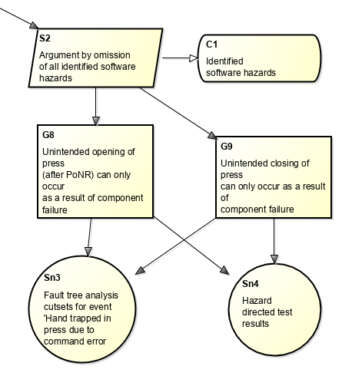

Figure : GSN Diagram Example

Figure 1 shows part of an example GSN diagram with two goals (G8, G9), two solutions (Sn3, Sn4), one strategy (S2) and a context (C1) element. GSN shows the claims (goals) and the evidences (solutions) and their relationships. Between claims and sub-claims, there can be strategy elements for the reasoning step. For indicating claims or reasonings context, context elements could be used. Additional assumptions and justifications can be added to GSN.

Astah GSN is one of the most full-featured commercial GSN diagram tools. It has several features for easier usability. These features vary from diagram styling to different types of file export. For instance, the alignment feature makes it easier to edit the diagram’s shape end elements’ position. Different export or import filetypes such as XMI, diagram image or MindMap increase Astah GSN’s usability with other model management tools. Last and one of the important features is model validation and fix. Astah GSN can validate drawn models and can fix them with a click.

## Epsilon

Epsilon (Extensible Platform of Integrated Languages for mOdel maNagement) is a platform for model management operations such as validation, transformation or code generation [10], [11]. Epsilon has ten different languages for different model management tasks. Epsilon Object Language (EOL) is the base language for all other task-specific Epsilon languages [12]. All other languages inherited from EOL and they all use EOL syntax for reducing repetition and better intelligibility [11]. Kolovos et al. [11] state that EOL’s main aim is to be a core language for *higher-level task-specific* languages, however; it can also be used for model access and modification operations. That’s why developing an Epsilon driver for EOL basics is adequate.

Epsilon is modelling technology agnostic. This means that all languages in Epsilon, including EOL, can be used to access and manipulate models in a variety of modelling technologies, including EMF, XMI, spreadsheets, Simulink and numerous others. This is enabled by the Epsilon Model Connectivity (EMC) layer, which is based on the driver design pattern. Every modelling technology that is desired to be manipulated by Epsilon requires a driver. EMC abstracts from all different models using the IModel interface [11]. The Epsilon Book [11] explains that the EMC layer handles the file and model operations such as model loading, type&ownership operations and creation/deletion/modification operations on the model. All these operations could and should be customized for each modelling technology. Some of the model connectivity drivers such as Plain-XML or UML model come with Epsilon installation. However, for other models, users need to create a new driver or may check the Epsilon Labs GitHub repository for the driver.

Epsilon supports most of the common models like UML, EMF, XML and many others. Nonetheless, it doesn’t support every existing model. Drivers are needed to work on models in the Epsilon platform and many commercial modelling tools don’t have a driver for the Epsilon. Most of the commercial tools are not open-source thus developing Epsilon drivers for these tools is harder. This causes a technological gap between closed-source model tools and open-source model management tools [13]. Open-source model management tools like Epsilon are developing day by day but commercial tools are mostly stuck in the same position by their developers' support. Using open-source model management tools instead of commercial model tools built-in management tools would benefit the company that is using these. However, developing an Epsilon driver for a commercial tool is a challenging task and it might take a serious amount of time. For instance, as demonstrated in [13], developing a driver for Rolls-Royce’s safety-critical systems is very challenging and the driver requires high-performance management for very big models.

This project is at the intersection of Model-Driven Engineering and safety, focusing on bridging commercial and open-source tools. This will be carried out by developing an Epsilon driver for Astah GSN. Astah GSN is a commercial tool and does not provide an easy-to-use API for programmatically and externally manipulating models. Hence, it is useful to build an Epsilon driver for Astah GSN. As we will see, building this atop existing drivers, especially the XML driver for Epsilon, will allow us to produce a quality solution within the time constraints of this project.

# REQUIREMENTS

The main goal of the project is to be able to use Epsilon to manage Astah GSN models. To support this, an Epsilon driver for Astah GSN must be produced. This driver will need to be able to parse Astah GSN correctly. Astah GSN saves its model files with an ‘.agml’ extension and this is a proprietary format that cannot be parsed and manipulated directly. However, it also provides XMI import/export features for GSN models, and it is through this that we will develop an Epsilon driver.

Developing an Epsilon driver involves implementing a number of interfaces from the Epsilon Model Connectivity (EMC) layer. By doing so, this allows Epsilon programs written in the core language (Epsilon Object Language, EOL) to manipulate Astah GSN models. As a side-effect, because of the architecture of Epsilon, this also means that the ten task-specific languages of Epsilon can manipulate Astah GSN. This is because the task-specific languages are derived from EOL thus, integrating models to EOL is sufficient for all other language support.

The requirements of this driver project have been collected by careful analysis of the capabilities of Astah GSN and the technical design of Epsilon (particularly EMC). Listed requirements were generated by the author after examining GSN diagrams, Astah GSN XMI files, similar Epsilon drivers, and Epsilon source code. Of particular importance were element access requirements, which are based on GSN standards; and attribute access requirements, which are based on both GSN and Astah GSN XMI files. For instance, ID access was originated from the GSN diagram’s element ID on the other hand XMI:ID was originated from the XMI tag attribute which stores the unique ID value for each tag element.

The requirements for this project are, therefore, entirely technical and focus on the system to be implemented, rather than on user requirements.

1. Users should be able to load Astah GSN models into Epsilon.
2. Users must be able to read/access the GSN models with Epsilon Object Language (EOL).
   1. Users should be able to access the entire GSN model
   2. Users should be able to access certain types of elements
      1. Accessing to all nodes
      2. Accessing to all links
      3. Accessing certain types of nodes (e.g. goals)
      4. Accessing certain types of links (e.g. asserted evidence)
   3. Users should be able to access a specific element in a GSN model.
      1. Accessing a specific node
      2. Accessing a specific link
   4. Users should be able to access elements’ attribute values
      1. Accessing an element’s content
      2. Accessing an element’s ID
      3. Accessing an element’s type
      4. Accessing an element’s XMI:ID
      5. Access an element’s XSI:TYPE
      6. Access a node element that is the ending point of the specific link
      7. Access a node element that is the starting point of the specific link
3. Users should be able to update GSN models with EOL.
   1. Updating an element’s content
   2. Updating an element’s ID
   3. Updating an element’s type
   4. Updating an element’s XMI:ID
   5. Updating an element’s XSI:TYPE
   6. Updating an element’s target link
   7. Updating an element’s source link
4. Users should be able to create new elements and append new elements in a GSN model with EOL.
5. Users should be able to delete elements in a GSN model with EOL.
6. Users should be able to validate an Astah GSN model with the Epsilon Validation Language (EVL).
7. Users should be able to transform an Astah GSN model to another model with Epsilon Transformation Language (ETL).
8. Users should be able to generate code or text from an Astah GSN model with Epsilon Code Generation Language (EGL).

In this chapter, project requirements and how/where they are collected was explained. The next chapter will analyze the design decisions of the project and what kind of changes/updates were made to the Astah GSN driver for Epsilon while developing it.

# DESIGN

Designing an Epsilon driver from scratch is very challenging. It takes a lot of time but fortunately, Epsilon has lots of built-in and external drivers for a number of different modeling technologies. It was easier to start with a similar model driver’s source code, on which the Astah GSN driver could be constructed. The most similar drivers that could be used in the design of the Astah GSN driver were the internal Plain-XML driver and external HTML driver. While designing the Astah GSN driver, these two drivers and their features helped me a lot. Both drivers and how they are used in this project will be explained in this chapter.

While developing the driver and the project, the waterfall methodology was used informally (i.e., in terms of gathering requirements, design, implementation), but some changes were made while developing the project due to uncertainties. The first step of the project was examining the GSN diagrams and learning the basics of their syntax. The next step was looking for similar Epsilon drivers, their element access operations and how they go about parsing the model files. Then project requirements were created based on collected information from GSN and similar drivers. The next step was looking for Epsilon driver projects to build upon. For that purpose, I used the Epsilon HTML driver and build Astah GSN parser on top of that project. The last step was testing the implementation of the driver on examples. In this step, Epsilon ran in debug mode and each step of model processing was investigated. Some necessary updates made in the source code and all of the changelog can be found in the project’s GitHub repository.

The Plain-XML driver comes with the default Epsilon installation. It is an internal model driver like EMF (Eclipse Modeling Framework) or UML (Unified Modeling Language) model drivers. Since Astah GSN uses XMI (XML Metadata Interchange) files, using the Plain-XML driver and its methods could make it easier to develop this project. At first, I examined the Plain-XML driver’s source code and how it works. For that reason, I ran Epsilon from source code in Eclipse and debugged the Plain-XML driver while running the EOL script on XML files.

Plain-XML driver can parse XML files and allows users too load, read and update XML models in Epsilon. However, after some experimentation I determined that this driver is not useful for Astah GSN XMI files. Astah GSN XMI files store every element in the GSN model with the same tag name (*argumentElement*), but the Plain-XML driver parses files via different tag names. User can access different elements, their child elements and their attributes with the tag name parameter. However, Astah GSN uses XML attributes to store every elements’ values such as type, content, and ID. Therefore, the Plain-XML driver would need to be heavily modified for parsing attribute values instead of tag names.

Unlike the Plain-XML driver, the HTML driver doesn’t come with Epsilon installation. Instead, the user has to get the HTML driver from Epsilon Labs [14] GitHub page and then has to run Eclipse from source to use it. For the Astah GSN driver project, using the HTML driver as a base project made developing a driver plugin for Epsilon easier for me. Like the Plain-XML driver, I examined the HTML driver and its source code and debugged it several times. But, the HTML driver doesn’t have as much source code as the Plain-XML driver. It just parses HTML files and then calls the Plain-XML driver’s methods. At the end of the day, HTML is a subset of XML and using the Plain-XML driver methods would make sense. However, that means I couldn’t use the HTML driver source code as a base project because most of its class is useless for the Astah GSN XMI file parser. So instead, I used the HTML driver for its Epsilon plugin features. Every name in the HTML driver’s plugin packages changed to “Astah GSN” thus, new project packages for the project created. More details about HTML will be explained later in Section 4.3.

## Implementing an Epsilon Driver for a Commercial Tool

There are several Goal Structuring Notation diagram tools out there. However, this project was developed for General Motors and they were using Astah GSN for their main GSN diagram tool. Moreover, Astah GSN has many features that other GSN tools don’t have. But, this doesn’t mean Astah GSN is perfect. It is a commercial tool and most of the methods that they used in Astah GSN are proprietary. That’s why I couldn’t use the Astah GSN model files (.agml) directly while developing the Epsilon driver; I have to use its XMI import/export function to access the GSN model.

XMI import/export functionality is a good feature but, like Astah GSN it’s not perfect. For instance, some node elements in the XMI file uses the same type of attribute values and as a result it’s hard to identify element types. Also, the exported XMI file doesn’t store the GSN diagram (the concrete syntax), it only stores elements (abstract syntax). Thus after importing the XMI file back into Astah GSN, the user has to drag and drop each element from the right side to the main area to create the GSN diagram again. After dropping node elements, it connects them correctly via link elements. Nonetheless, not storing the diagram is a huge downside for using XMI files instead of AGML files. Another negative aspect of using XMI is that it does not store every link element. For example, it doesn’t store Goal-to-Strategy and Strategy-to-Goal link elements in the file. Instead, Astah GSN stores Goal-to-Strategy-to-Goal relationships as Goal-to-Goal links and records these link elements’ *xmi:id* in the Strategy elements’ *describedInference* attribute. These kinds of defects make it challenging to develop an Epsilon driver for Astah GSN. We discuss these challenges further in the next sections.

## XMI File and Element Attributes

XMI (XML Metamodel Interchange) is an OMG (Object Management Group) standard format for interchanging MOF (Meta Object Facility) models [15] such as GSN. Astah GSN could export GSN models as XMI files. In XMI format, all elements use the same tag name except the root element. All element features like type, ID, and even content are stored in the element attributes. An XML parser is by definition able to parse XMI files, but it will be unaware of its semantic content, particularly the types of elements. More specifically, Epsilon’s Plain-XML driver could parse the given Astah GSN XMI file but the user cannot access all types of elements because Plain-XML driver lacks the capability to parse by attribute features. The new Astah GSN driver developed in this project provides attribute parser and other additional features for Astah GSN models. With this driver, the user should be able to access or update each elements’ attributes by correct commands.

Goal Structuring Notation consists of six node types and two relationships (link) types. However, Astah GSN doesn’t use the same element types as GSN Standards. Node elements are the same but Astah uses more than two link types in the XMI document. Table 1 shows the GSN Standard’s element types and Table 2 shows the Astah GSN XMI file’s element types.

|  |  |
| --- | --- |
| **Node Elements** | **Link Elements** |
| * Goal * Strategy * Solution * Context * Assumption * Justification | * SupportedBy (goal-to-goal, goal-to-strategy, goal-to-solution, strategy-to-goal) * InContextOf (goal-to-context, goal-to-assumption, goal-to-justification, strategy-to-context, strategy-to-assumption and strategy-to-justification) |

Table : GSN Model Standard Element Types

|  |  |
| --- | --- |
| **Node Elements** | **Link Elements** |
| * Goal * Strategy * Solution * Context * Assumption * Justification | * Asserted Inference (goal-to-goal) * Asserted Evidence (goal-to-solution) * Asserted Context (goal-to-context, goal-to-assumption, goal-to-justification, strategy-to-context, strategy-to-assumption and strategy-to-justification) |

Table : Astah GSN Element Types

Astah GSN uses XML attributes to store all data in the XMI formatted file. All elements (except root) uses the same tag name but they all use different attributes and attribute values. Table 3 shows the GSN element (tag name: argumentElement) attributes and their description.

|  |  |  |
| --- | --- | --- |
| **Attribute Name** | **Element Type** | **Description** |
| xsi:type | All elements | Element’s type (Some node types have the same xsi:type attribute) |
| xmi:id | All elements | Unique ID for each element |
| ID | All elements | Element’s ID shown in the GSN diagram (e.g. G1) |
| Description | All elements | Description of the element (Mostly empty) |
| Content | All elements | Content of the element that is shown on the GSN diagram |
| URL | Nodes (Solution, Context) | Hyperlink of the attached documents |
| Assumed | Nodes (Goal, Assumption, Justification) | Assumption element’s value is true, Goal and Justification elements are false |
| ToBeSupported | Nodes (Goal, Assumption, Justification) | Undeveloped goal element’s attribute value is true |
| DescribedInference | Nodes (Strategy) | Strategy element’s InContextOf relationships with Goal elements |
| Target | Links | Link element’s source node xmi:id (In Astah GSN, target and source are reversed) |
| Source | Links | Link element’s target node xmi:id (In Astah GSN, target and source are reversed) |

Table : Astah GSN XMI document attributes

## Using the Epsilon HTML Driver

There are multiple built-in drivers for different models in the Epsilon. However, I needed to create a new driver plugin for Astah GSN models. Therefore, I searched for other model drivers for Epsilon that aren’t built-in. EpsilonLab’s GitHub page [14] has several EMC drivers for different models such as HTML, JDBC, JSON, and more. The most similar model driver to Astah GSN was HTML, because HTML and XML/XMI share a tree-like structure.

After cloning the EMC-HTML git repository, I tried to run it on the Epsilon source code. The first step was importing the two HTML project packages into Eclipse Epsilon workspace. Even though the HTML repository has six different packages, only two of them are necessary for running the HTML driver. The other four packages are test and example packages. After that step, the Epsilon source code rebuilds itself. Then running Epsilon on the new Eclipse application is sufficient for the HTML driver. The new driver creates an Epsilon model selection in the Run Configuration of every Epsilon language. For testing purposes, I created a new EOL file. Then I created a new run configuration for this EOL file and HTML Document was one of the model options in the Model Selection tab. After selecting it, the EOL script will use an HTML file as a model.

Since I had no experience with Epsilon plugin development, I used the HTML driver as a base plugin project. I changed all names in the project and used a new image for the Astah GSN model selection tab. After that, I examined the HTML driver classes. The main class is called the HTML model and it invokes getter and setter classes for different functionalities. However, HTML getter and setter methods only call Plain-XML getter and setter functions. Therefore, I used Plain-XML drivers functions for the getter, setter and model classes. This is an important point to clarify: the HTML and Plain-XML drivers are interdependent. In Astah GSN, both are therefore used to support necessary functionality, though the high-level structure of the driver is derived from the HTML driver.

I used an HTML driver for plugin features and changed all models, getter, and setter classes/methods. The HTML driver used Java Jsoup library for HTML element parsing. This library could also parse the XML/XMI files but each time this library is used, it adds <html> and other main tags into the XML file. So, I changed this library to use the Plain-XML driver’s parser library.

## Using the Epsilon Plain-XML Driver

As stated, the HTML plugin was the most similar example to Astah GSN driver that I am going to work on. But the parsing methods in the HTML driver weren’t directly useful for the XMI file parser. That’s why the HTML driver project was used for only Epsilon plugin features and all other classes like the model, getter, and setter were based on Plain-XML driver.

The Plain-XML driver’s main goal is parsing given XML files based on tag names. For this reason, it uses Java W3C Dom library’s Node and Element classes. Each element represents a tag object. Elements store tag’s attributes, text, and its child tags. Plain-XML driver’s classes parse XML files based on tag names. However, the Astah GSN XMI file uses the same tag name for every element and it uses attributes to determine element types. Thus, the Plain-XML driver has to be modified for parsing attributes instead of tag names. To do these modifications model, type, getter, and setter classes and their methods have to change. The basic changes in each class will be explained in Chapter 5.

The model class is the main class of the driver. It is responsible for file operations, model operations, invoking getter and setter classes, element creation, and removal operations. This class wasn’t modified much because file, model, getter, and setter operations are the same for XML and XMI files. The only modification made in the element creation function. Plain-XML driver’s element creator function was using tag names for new elements. But, Astah GSN XMI driver doesn’t require tag names because all elements use the same tag name. Thus this function changed for getting GSN element’s type instead of getting the tag names as a function input.

Type class in Plain XML has four types for XML files. These are *tag, attribute, reference,* and *child*. But these types are not necessary for the Astah GSN driver. Thus, types are changed to GSN model elements such as goal, strategy, solution, etc, as these are more readable (in the source code) and the resulting code will hopefully be easier to maintain.

Getter and setter classes are heavily modified based on the Astah GSN XMI file. These two classes parse the XMI file based on attributes. All classes and their methods are explained in *Section 5: Implementation*.

## Determining Element Types in the XMI File

Determining element types such as Goal, Solution or Asserted Evidence is one of the most important parts of the Astah GSN Driver. In an early design, each user query was parsed before accessing the element in the XMI file. Thus, if the given query element wasn’t in the GSN type, it would return an empty result. For example, a user can only get elements with IDs like G1, Sn4, C2, … These IDs are created by Astah GSN with element type data; specifically, goal element IDs starts with G, Solution with Sn and Context with C. However, element IDs don’t have to start with element type letters. In this case, the GSN type parse function for custom IDs such as CA1, AR-C1 returned null and Epsilon showed an error.

In later designs, a custom ID access added to the driver, because GSN standards don’t require IDs to start with element type letters. That’s why instead of returning null for custom ID queries, the driver compares every ID in the model and if it cannot find it, then it returns null. For custom IDs, GSN type parser still returns null but after that, it checks every element for custom ID probability.

Another update for not determining types with element ID would be the “.gsntype” query. Before this change, the node elements’ type was found by element IDs and link elements’ type were found by *xsi:type* attribute. After discovering custom IDs, the *gsntype* function has to change. However, there is a problem with determining element type without IDs. The only way to finding element types is the *xsi:type* attribute. But, some of the node elements use the same xsi:type attributes. For instance, Goal, Assumption, and Justification elements all use “ARM:Claim” value for *xsi:type* attribute. So, for determining types, I have to use other attributes. The only difference between Goal-Justification pair and Assumption elements is assumed attribute. For Assumption elements this attribute’s value is true but for Goal and Justification elements this attribute’s value is false. Now we can determine Assumption elements from Goal and Justification elements. For determining between Goal and Justification elements, there aren’t any attributes. The only difference between these 2 elements is their connections. Goal elements can connect all 3 types of link elements but Justification elements can only connect to the Asserted Context element’s target side. Thus, if the given element’s *xmi:id* stored in one if the Asserted Context attributes’ target attribute, that means the element’s type is Justification.

The Goal-Justification situation is the same for Solution-Context pairs. Instead of “ARM:Claim” *xsi:type* attribute Solution-Context elements use “ARM:InformationElement”. Similarly, Context elements can only be connected to Asserted Context links’ target side. Hence, the same function used for determining Justification and Context elements. All types of element examples could be seen in Table 4.

|  |
| --- |
| **Goal element** |
| <argumentElement xsi:type="ARM:Claim" xmi:id="_fvLpEJq4EeqyzooT9RpXrQ" id="G1" description="" content="Control System is acceptably safe to operate" assumed="false" toBeSupported="false"/> |
| **Assumption element** |
| <argumentElement xsi:type="ARM:Claim" xmi:id="_fvLpI5q4EeqyzooT9RpXrQ" id="A1" description="" content="All hazards have been identified" assumed="true" toBeSupported="false"/> |
| **Justification element** |
| <argumentElement xsi:type="ARM:Claim" xmi:id="_fvLpJJq4EeqyzooT9RpXrQ" id="J1" description="" content="SIL apportionment is correct and complete" assumed="false" toBeSupported="false"/> |
| **Solution element** |
| <argumentElement xsi:type="ARM:InformationElement" xmi:id="_fvLpE5q4EeqyzooT9RpXrQ" id="C1" description="" content="Operating Role and Context" url=""/> |
| **Context element** |
| <argumentElement xsi:type="ARM:InformationElement" xmi:id="_fvLpH5q4EeqyzooT9RpXrQ" id="Sn1" description="" content="Formal Verification" url=""/> |
| **Strategy element** |
| <argumentElement xsi:type="ARM:ArgumentReasoning" xmi:id="_fvLpF5q4EeqyzooT9RpXrQ" id="S1" description="" content="Argument over each identified hazards" describedInference="_fvLpM5q4EeqyzooT9RpXrQ _fvLpNJq4EeqyzooT9RpXrQ _fvLpNZq4EeqyzooT9RpXrQ"/> |
| **Asserted Context element** |
| <argumentElement xsi:type="ARM:AssertedContext" xmi:id="_fvLpJZq4EeqyzooT9RpXrQ" id="" description="" content="" source="_fvLpFJq4EeqyzooT9RpXrQ" target="_fvLpEJq4EeqyzooT9RpXrQ"/> |
| **Asserted Inference element** |
| <argumentElement xsi:type="ARM:AssertedInference" xmi:id="_fvLpJ5q4EeqyzooT9RpXrQ" id="" description="" content="" source="_fvLpEZq4EeqyzooT9RpXrQ" target="_fvLpEJq4EeqyzooT9RpXrQ"/> |
| **Asserted Evidence element** |
| <argumentElement xsi:type="ARM:AssertedEvidence" xmi:id="_fvLpL5q4EeqyzooT9RpXrQ" id="" description="" content="" source="_fvLpIZq4EeqyzooT9RpXrQ" target="_fvLpHZq4EeqyzooT9RpXrQ"/> |

Table : Example Element Tags from Astah GSN XMI File

## Problems with Astah GSN XMI Files

Astah GSN’s XMI import/export feature is relatively immature compared to its GSN diagram features. There are three design decisions that I encountered while working with its XMI files. These three methods led to complications in the driver and made it difficult to implement the Epsilon driver. The first issue is about the link elements’ target and source attributes. For some reason, the link element’s target and source attributes are reversed. Target attribute stores the starting node element’s *xmi:id* value and source stores the node element that link finishes (The direction indicated by the arrow). In this project, target and source access in Epsilon isn’t reversed as in the XMI file. This makes usability better for users.

The second problem is caused by some of the links in the GSN diagram. Most of the links such as Goal-to-Goal, Goal-to-Context, Goal-to-Solution, Strategy-to-Assumption stored as link elements with target and source attributes. However, Goal-to-Strategy and Strategy-to-Goal links aren’t stored as link elements. Instead of this method, Astah GSN stores Goal-to-Strategy-to-Goal links as a link element (Goal-to-Goal) and stores this link element’s *xmi:id* in-between strategy element’s *describedInference* attribute. Table 4 shows an example Strategy element. This Strategy element (S1) has four connections to four different Goal elements but XMI file has three different link elements. Rather than G1-to-S1, S1-to-G2, S1-to-G3 and, S1-to-G4 links, XMI file stores G1-to-G2, G1-to-G3 and, G1-to-G4 links. It also has these three link elements’ *xmi:id* inside S1’s *describedInference*.

The last problem is the *xmi:id* usage. When you export the GSN diagram as XMI file, it generates a unique ID for the root element and it uses the root element’s ID to generate child elements *xmi:id* attribute. However, if the user changes something in the GSN diagram (e.g. add another node), it completely changes all ID values. This is not a huge concern in the project but I cannot generate the unique *xmi:id* values for newly created elements because I don’t know what values Astah GSN uses when generating these IDs.

Chapter 4 presented the design and the challenges of the Astah GSN driver development process. It also mentioned why two of the selected Epsilon drivers are chosen over others and how I took advantage of each of them while designing this project. There were also some problems and challenges while developing this project due to Astah GSN limitations. In the next chapter, the implementation progress of the chosen design layouts, as well as each developed classes and their methods, will be discussed.

# IMPLEMENTATION

Epsilon developed with Java and all Epsilon languages run on Java. Epsilon source code consists of several Java projects. Some of the project types are EOL engine, features, plugins, and tests. The model drivers like UML and Plain-XML are plugin projects. However, each driver has more than one Java project. For instance, the Astah GSN driver consists of two different Java projects. The first one has Model features such as getters and setters, and the second one has Epsilon plugin features. The plugin project and its features didn’t change much other than the plugin name variables. The crucial changes are made in the first project folder named “org.eclipse.epsilon.emc.astahgsn”. Since it is a driver project, it is in the EMC (Epsilon Model Connectivity Layer) layer.

Five Java classes implemented in this project. These five classes and their content gathered from Epsilon Plain-XML driver and then their methods heavily updated by me. Names of these five classes are GsnModel, GsnProperty, GsnPropertyType, GsnPropertyGetter, and GsnPropertySetter. Classes and their methods will be explained in the subsections.

## GSN Model

GSN Model is the Astah GSN driver’s main class. It consists of file operations, model load/store operations, all elements collector, new element creator, and element removal methods.

XMI uses XML structure therefore, Plain-XML driver’s file operations weren’t changed in the Astah GSN driver. Moreover, model loading and storing functions as well as removing an element and collecting all elements functions are the same as Plain-XML driver. Most of the changes done within new element creation, and *owns* function.

Plain-XML element creator function was using tag name for new elements but the Astah GSN XMI file uses the same tag name for all elements except root tag. The new function takes as a type parameter and parses it in the GsnProperty class. It returns the element’s type such as Goal, Strategy, or root. Then new attributes and values are created with type data. All node and link elements have five common attributes: *xsi:type, xmi:id, id, content, and description.* *Content* and *description* attributes created empty. *Xsi:type* value comes from the GsnProperty class’s parser function. *Id* value also comes from GsnProperty parse function but it only consists of the new element’s type prefix such as G for Goal typed element. The hardest part was generating new *xmi:id* for the new element. Each element unique value and Astah GSN uses the root element’s *xmi:id* to generate new *xmi:id* values for each element. Since I don’t know which parameters Astah GSN uses for ID generation, I couldn’t implement a working ID generator. So, instead of empty *xmi:id* values, current function puts type prefix letter + “MustBeUnique” string in the *xmi:id* attribute. For example, a new goal element’s *xmi:id* attribute value will be “GMustBeUnique”.

Another difference between Plain-XML and Astah GSN drivers would be appending new elements into the model. Plain-XML driver appends new elements into the model when they are created but Astah GSN doesn’t append them to model directly. Appending requires another command which is “.append”. This function will be explained in the setter class.

*Owns* function in model class responsible for calling the right class functions. For instance, if *owns* function returns false for given input then it calls the superclass of the GsnProperty which is JavaProperty. JavaProperty class doesn’t have any XML parser so, for correct elements, the *owns* function has to return true so that model class can call GsnProperty class. One more condition added to the *owns* function. This one is added for getting the root element from the XMI file so that if the Epsilon returns the root element, the *owns* function returns true.

## GSN Property

GsnProperty is a parser class. It parses given elements and returns a newly created GsnProperty object. This class consists of a few protected attributes.

* ***GsnPropertyType* gsnPropertyType:** Type of the element (e.g. **Goal**)
* ***String* idPrefix:** Element type ID prefix (e.g. **G** for Goal).
* ***String* xsiType:** *xsi:type* attribute value for given type (e.g. **ARM:Claim** for Goal).
* ***boolean* isNode:** Is the element a node or not?
* ***boolean* isLink:** Is the element a link or not?
* ***boolean* isRoot:** Is the element the root or not?

There are also three functions in this class. Two of them are parser and the last one is element type determiner. The first parser class gets string input and parses it. This string input could be ID like G1, A4, J5, or a type name like a solution, strategy, … With these inputs, it creates a new GsnProperty object, assigns the above variables according to the element type, and returns it. If it couldn’t parse the given string properly, it returns null. Elements with custom ID values return null by this parser function so they use second parser function. This parser function gets an element object as an input and parses it by *xsi:type* attribute. Nonetheless, some elements have the same values for *xsi:type*. In this case, the parser function calls the third function which is “isJustificationOrContext”. This function determines if the given element Goal or Justification and also Solution or Context. As mentioned before, Context and Justification elements only connect to the Asserted Context link’s target side. So, this function checks every Asserted Context elements’ target attribute and if it finds the given element’s *xmi:id* in them, it returns true. Otherwise, it returns false.

## GSN Property Type

This class only consists of element types enumeration. Six node types plus three link types and the total nine GSN types. All element types are listed below:

* Goal
* Strategy
* Solution
* Context
* Assumption
* Justification
* AssertedInference
* AssertedEvidence
* AssertedContext

## GSN Property Getter

Getter class is used for all element access queries. There are several different getter commands in the Astah GSN driver and all of them are in the invoke the function. There are major design changes in the getter class and its methods. The Plain-XML driver uses tag names to parse the XML file. For instance, “t_argumentElement.all” is an example Plain-XML query in EOL. On the other hand, Astah GSN XMI file’s tag names are fixed and they don’t change with element types. So, using tag names in the EOL query isn’t necessary for the Astah driver. Instead, I used a “gsn” keyword to parse the file and get the root element. After the “gsn” keyword, the users can type the element they want to access. For example, for accessing the goal elements the users need to type “gsn.goal” or for accessing an assumption element with ID: A4, they need to type “gsn.A4”.

The major change part is the element access. The Plain-XML driver requires “.all” keyword to get all the tag elements. For example, “t_argumentElement.all” query parses the file gets all elements with *argumentElement* tag name. If you want to get the id attribute values of these tags, you need to type a query like “t_argumentElement.all.a_id”. Without *all* keyword such as “t_argumentElement.a_id” the Plain-XML driver won’t work. However, in the Astah GSN driver, you don’t need to use the *all* keyword to access any element. For this change to happen, I need to modify the *owns* function in the GsnModel. *Owns* function returns true to all *Element* (W3C Dom library’s Element class) types and also *EolModelElementType* objects with the “gsn” keyword. So, all queries that start with the “gsn” keyword invoke the GsnPropertyGetter and GsnPropertySetter classes. If the *owns* function returns false for the input object, it invokes the superclasses which are JavaPropertyGetter and JavaPropertySetter. Nonetheless, these two classes cannot parse the XMI file so invoking the right classes is a very important aspect of this driver project.

In the Plain-XML driver, “.all” request handled by the JavaPropertyGetter, not by the PlainXmlPropertyGetter. “.all” request parses the file and collects all elements with the given tag name. On the other hand, in the Astah GSN driver, “.all” requests handled by the GsnPropertyGetter class thanks to modified GsnModel's *owns* function. Without *EolModelElementType* acceptance in the GsnModel’s *owns* function, Astah GSN queries have to use “all” keyword such as “gsn.all.G1” instead of “gsn.G1”. Nevertheless, “.all” queries handled the same as “.goal” or “.nodes” queries thanks to this modification.

As mentioned before, the “gsn” keyword represents the root element of the XMI file. All other elements are children of the root element. Some queries like “gsn.all” or “gsn.strategy” return element Sequence which is a list type of the Epsilon languages, other queries such as “gsn.J4” or “gsn.t_g1_s_s2” return only one element object. There is also the third type of queries which returns a string as a result. Queries like “gsn.Sn2.id” or “gsn.goal.content” return String or String Sequence depending on the number of the elements.

1. **All elements**

Keyword: all

Returns: NULL or 1+ elements

Description: This command’s input parameter is the root element. The function parses child elements and returns them as an Epsilon’s sequence type.

1. **All node elements**

Keyword: nodes

Return Type: NULL or 1+ elements

Description: Nodes command parses the root element and creates a new list with only node elements. Node elements have non-empty ID attributes. It loops over all child elements and only adds elements with non-empty ID attribute into the result list.

1. **All link elements**

Keyword: links

Return Type: NULL or 1+ elements

Description: Links command works similar to nodes command. It parses root element, loop overs every child, and only adds elements with empty ID into the list. Then it returns the result list.

1. **Element by type**

Keywords: goal, strategy, solution, context, assumption, justification, assertedcontext, assertedevidence, and assertedinference

Return Type: NULL or 1+ element

Description: Element types are determined via GsnProperty parser. This part loops over every child element and calls parser to determine the element’s type. If the types are a match, it adds elements to the result list. Finally, it returns the result list.

1. **Element by ID**

Keywords: G1, Sn2, … (GSN Element ID)

Return Type: NULL or 1 element

Description: There are two types of search by ID methods: proper ID and custom ID. Getting element by ID is the last case in the invoke function. The proper ID part (e.g. G4, S2, C1) calls GsnProperty parser with a string ID variable. If it can parse it. It will return a new GsnProperty object. Then, it checks every elements’ ID and if it can find it, it returns the element. Custom ID part works the same bu it only invokes this part after returning null from GsnProperty parser. If there wasn’t any element with a given custom ID, invoke function returns null.

1. **Link element with source and target IDs**

Keywords: s_ID1_t_ID2 or t_ID1_s_ID2

Return Type: NULL or 1 element

Description: This case takes string input like “s_G1_t_C2” and parses it to get two-node ID values. The reason I used “_” characters between each part is, Epsilon doesn’t work with “–“ character. After parsing sting, it finds node elements with given two IDs. If both of the nodes are found, it loops over every link element and tries to find given nodes *xmi:id*s in the target and source attributes. Finally, it returns the link element or null depending on a search result.

1. **Element’s type**

Keyword: gsntype

Return Type: Empty string or type string

Description: Gsn type case’s input could be a root element, list, or just an element. It uses the GsnProperty element parser to determine the given element/s type and returns it. Additionally, the “gsntype” keyword used instead of the “type” keyword because the “type” keyword used by Epsilon and it returns the given object’s type.

1. **Element’s target**

Keyword: target

Return Type: NULL or 1+ elements

Description: Target getter works differently for node and link elements. If the element is a node, it returns the given node’s all links that are targeted to the given node. If the element is a link, it returns the link’s targeted node element.

1. **Element’s source**

Keyword: source

Return Type: NULL or 1+ elements

Description: The source case works the same as the target case. The only difference is, it checks the source attribute instead of the target attribute.

1. **Element’s content**

Keyword: content

Return Type: Empty string or content string

Description: This case directly returns the given element/s content string.

1. **Element’s ID**

Keyword: id

Return Type: Empty string or ID string

Description: Returns given element/s ID value/s.

1. **Element’s *xmi:id***

Keywords: xmiid or xmi_id

Return Type: Empty string or xmi:id string

Description: Returns given element/s *xmi:id* value/s.

1. **Element’s *xsi:type***

Keywords: xsitype or xsi_type

Return Type: Empty string or xsi:type string

Description: Returns given element/s *xsi:type* attribute value/s.

In addition to the getter invoke method, three custom methods implemented from starch by me. These three methods are

* Find element by attribute name and value (Returns the element with the given attribute name and matched value)
* Get element attribute (Returns the given attribute names value)
* Find link by node IDs (Returns the link element with target and source IDs)

## GSN Property Setter

Every element value update calls use this setter class. Similar to getter class, setter class only uses one invoke function. Since all elements’ values cannot change, the setter class doesn’t have that many different commands.

1. **Set element’s content**

Keyword: content

Description: Sets the given element’s content attribute value.

1. **Set element’s ID**

Keyword: id

Description: The ID command sets the given element’s ID attribute.

1. **Set element’s *xmi:id***

Keywords: xmiid or xmi_id

Description: This command updated the given element’s *xmi:id* attribute value.

1. **Set element’s *xsi:type***

Keywords: xsitype or xsi_type

Description: Updated given element’s *xsi:type* attribute.

1. **Set the link element’s target**

Changes are given to the link element’s target attribute. It takes an ID as a string, finds the node with the given ID, gets node’s *xmi:id* attribute, and sets given link element’s target attribute to the new nodes *xmi:id*.

1. **Set the link element’s source**

Keyword: source

Description: Works like the target setter case.

1. **Set element’s GSN type**

Keyword: gsntype

Description: Takes new type string as an input. It calls GsnProperty parser to find the given type’s *xsi:type* value and sets it to the given element’s *xsi:type* attribute.

1. **Append a new element into the model**

Keyword: append

Description: Takes an element object as an input. If the new element object doesn’t have an ID with digits (e.g. G, S), it finds the highest ID number for the new element’s type and assigns the highest/largest ID to the new element. Then it adds the new element into the root element as a children tag.

Similar to the getter class, the setter class has a custom method as well.

* Get the highest number of given typed element ID (Returns the given types highest ID number. For example, if the input parameter is a *goal*, it finds the highest ID goal element such as G10 and returns 10 as a result.)

The implementation chapter focused on the classes, methods and descriptions. Chapter 6 will evaluate the testing phase and testing methods. The first subject will be the user guide of the driver and the second part will investigate the driver’s usability on real-world GSN diagrams.

# TESTING & EVALUATION

In this section, driver usage examples are given. Each requirement would be explained with examples.

## How to Use Astah GSN Driver?

### Loading the Astah GSN Model into Epsilon

Since this driver based on the Plain-XML driver, the loading model file operation is the same. The only difference between these two drivers is their names. For instance, the “Plain-XML Document” changed to “Astah GSN XMI Document”. Other than its name, the rest of the model loading operation works like a Plain-XML driver. The below steps explains how to load an Astah GSN model into Epsilon.

* 1. Create a new EOL file in Eclipse IDE with Epsilon.
  2. Right-click the EOL file and click *Run As* > *Run Configuration*.
  3. Choose *EOL Program* and create a new Run Configuration.
  4. Choose your EOL files in the *Source* tab.
  5. Go to the *Model* tab and click *Add* button
  6. Choose the *Astah GSN XMI Document* and click *OK* (Figure 2).

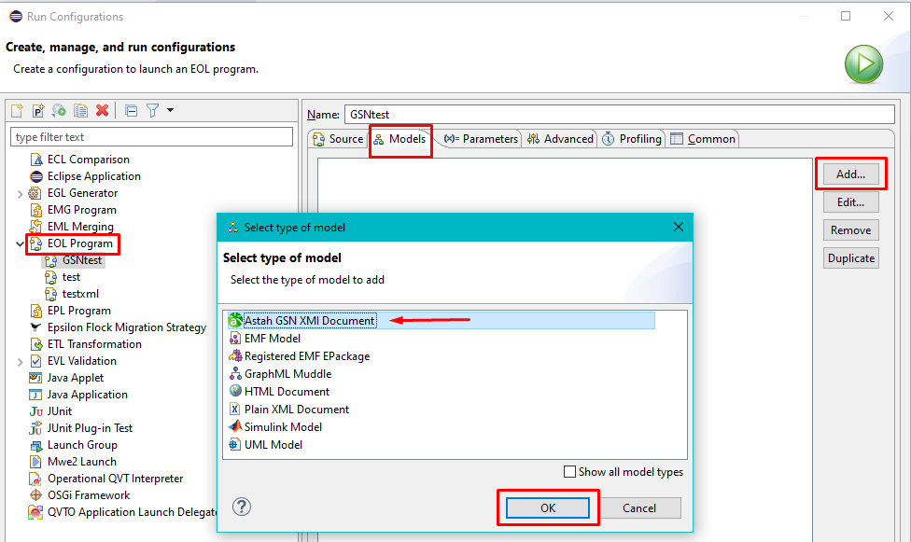

Figure : Loading Astah GSN model into EOL

* 1. Give a name to your model, it is not very important if you don’t want to use multiple models in the same EOL script.
  2. Choose your XMI file if it’s already in the workspace. If not, add your model file into the workspace.
  3. If you are going to update/modify the GSN model, choose both *Read on load* and *Store on disposal* options (Figure 3).

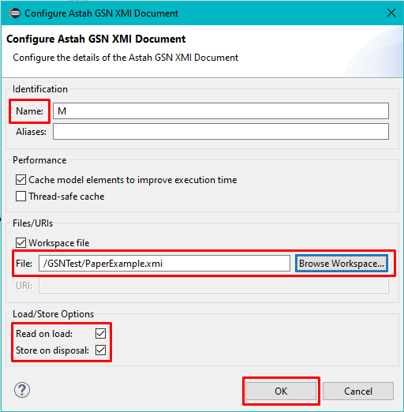

Figure : Loading model configurations

* 1. After that, you can run the EOL script with the *Run* button. EOL will run on your Astah GSN model (Figure 4).

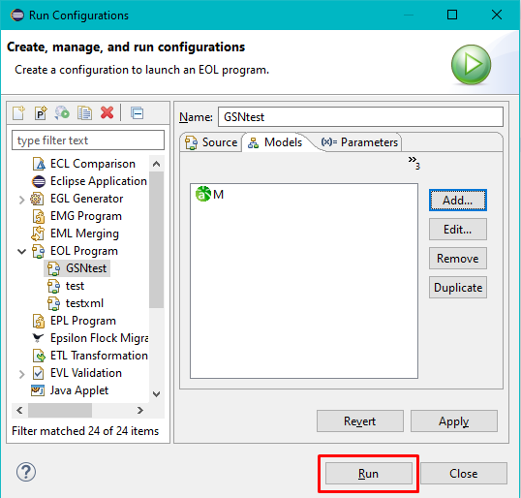

Figure : Running EOL with Astah GSN model

### Reading/Accessing GSN Models with EOL

Plain-XML driver has two classes for getters and setters. Reading and accessing model calls getter class functions. Astah GSN driver’s getter class completely changed and it has minimal similarities with Plain-XML getter class.

Most of the changes made for getting attribute values rather than tag names. Plain-XML getter class has a method for getting tags, child tags, attribute values, etc. In Plain-XML driver, users can only select different tag named elements but the Astah GSN XMI document requires getting different attribute valued elements.

Plain-XML documents can have several layered elements so the driver can get the root element or any child element. Astah GSN driver has two different options: getting the root element or root’s child elements. Because GSN XMI document only has the root element (tag name: ARM:Argumentation) and its child elements (tag name: argumentElement). Some of the methods get the root element and some of them only get children. For instance, *gsn* call parses the document and returns the root element. On the other hand, *gsn.goal* or *gsn.S4* calls to parse the document, find the specified child element/s, and return them as a list or a single element. Table 5 shows the attribute (value) access commands, Tables 6 and 7 present single and multiple element access commands respectively.

|  |  |
| --- | --- |
| **Attribute Getter Commands** | **Command Explanation** |
| gsn.all.content  gsn.context.content  gsn.Sn13.content | Returns specified element/s’ content attribute value/s. The results could be Sequence or string depending of an element. Link elements’ don’t have content attribute so it returns empty string (“”). |
| gsn.G1.gsntype | Returns given element/s’ GSN type |
| gsn.strategy.id  gsn.c23.id | Returns given element/s’ ID. Link elements’ don’t have ID thus it returns empty string. |
| gsn.a9.xmi_id | Returns given element/s’ xmi:id attribute. Each element has unique xmi:id values. |
| gsn.goal.xsi_type | Returns given element/s’ xsi:type attribute. Same elements (e.g. goal and assumption) have the same xsi:type values. |
| gsn.Sn3.target  gsn.t_g1_s_g2.target | Returns link elements that have target value as given node element/s. |
| gsn.g2.source  gsn.s_g2_t_g1.source | Returns link elements that have source value as given node element/s. |

Table : Astah GSN Driver Attribute Getters

|  |  |
| --- | --- |
| **Single Element Commands** | **Command Explanation** |
| gsn.G1, gsn.c12, gsn.S3, gsn.Sn7, gsn.a5, gsn.j9 | Returns node element with given ID value. |
| gsn.CA1, gsn.ERC1 (For ID: E-RC1) | Returns node element with given custom ID value. *Note: Custom ID queries cannot include non-alphanumerical characters.* |
| gsn.t_g1_s_g2 OR gsn.s_g2_t_g1 | Returns link element that has target value is G1 and source value is G2. |
| gsn.all.last | Returns the last element of the given element list |
| gsn.solution.first | Returns the first element of the given element list |

Table : Astah GSN Driver Single Element Getters

|  |  |
| --- | --- |
| **Multiple Element Commands** | **Command Explanation** |
| gsn.all | Returns all elements (Entire model) |
| gsn.nodes | Returns all node elements |
| gsn.links | Returns all link elements |
| gsn.goal | Returns all Goal elements |
| gsn.strategy | Returns all Strategy elements |
| gsn.solution | Returns all Solution elements |
| gsn.context | Returns all Context elements |
| gsn.assumption | Returns all Assumption elements |
| gsn.justification | Returns all Justification elements |
| gsn.assertedcontext | Returns all Asserted Context (link) elements |
| gsn.assertedinference | Returns all Asserted Inference (link) elements |
| gsn.assertedevidence | Returns all Asserted Evidence (link) elements |

Table : Astah GSN Driver Multiple Element (List) Getters

Some of the getters could be combined differently. For example, *gsn.goal.last.content.println()* and *gsn.goal.content.last.println()* prints the same result. The difference between these two commands is simple. The first command gets all goal elements list, then finds the last goal element and prints its content attribute value. The second command gets the goal elements list, then gets all goal elements’ contents and creates a new list later it prints the last content in that list. Thus, the first command is faster than the second one because it doesn’t get all goal elements’ content attribute, it just gets one goal element’s content attribute and prints it.

### Updating GSN Models with EOL

Updating elements command call setter class functions. Most of the element attributes can be set via the below commands. Getter and setter commands are the same. The only difference is setters require “=” character and new value after equals character. Table 8 indicates a few element update commands in Astah GSN driver.

|  |  |  |
| --- | --- | --- |
| **Setter Commands** | **Type** | **Command Explanation** |
| gsn.sn13.content = “New content”; | String | Updates the given element’s content value |
| gsn.g3.id = “G6”; | String | Updates the given element’s ID (ID attributes must be unique!) |
| gsn.j15.xmi_id = “fvLpH5q4Eeqyz11T9RpXrQ”; | String | Updates given element’s xmi:id attribute. However, Astah GSN generates unique xmi:id values based on model and element location. Therefore, using this command can corrupt the model file. |
| gsn.c7.xsi_type = “ARM:ArgumentReasoning”; | String | Updates given element’s xsi:type attribute. Changing xsi:type without changing id might corrupt model file. |
| gsn.t_s1_s_g1.target = gsn.sn7; | Node element | Updates the given link element’s target attribute to the new node element’s xmi:id. The new value must be a node element. |
| gsn.t_J1_s_G13.source = gsn.J2; | Node element | Updates the given link element’s source attribute to the new node element’s xmi:id. The new value must be a node element. |
| gsn.a12.gsntype = “goal”; | String | Updates the given element’s type attribute. Changing xsi:type without changing id might corrupt model file. |

Table : Astah GSN Driver Element Setters

### Creating New Elements in GSN Model with EOL

Creating a new element command uses a *new* keyword. Using a *new* keyword-only creates a new element object but it doesn’t append this new object into the model. Table 9 demonstrates a new element creation and attachment to model commands in EOL.

|  |  |
| --- | --- |
| **Creator Command** | **Command Explanation** |
| var newElement = new goal; | The *new* keyword creates a new element with the given type. |
| gsn.all.append = newElement; | *Append* command attaches a given element into the model file. A new element would be the last element in the model file. |

Table : Astah GSN Driver Element Creator Commands

The new element’s attributes could be set in two different ways. Either updating the *newElement* object like *newElement.content = “test”;* or accessing the last element and updating its attributes such as *gsn.all.last.content = “test”;*.

### Deleting Elements in GSN Model with EOL

Deleting an element in EOL uses a *delete* keyword. One or multiple elements could be deleted via *delete* command. Table 10 shows the element removal command in the driver.

|  |  |
| --- | --- |
| **Delete Command** | **Command Explanation** |
| delete gsn.G10; | Deletes given element/s. |

Table : Astah GSN Driver Element Delete Commands

### Epsilon Validation Language (EVL) Usage

Running EVL or other Epsilon language script in Astah GSN models requires the same steps as running EOL scripts. First, you need to load the model, choose the Astah GSN XMI file, and create a new run configuration for EVL to run it.

In this example, two different constraints added to the model. The first constraint covers all elements in the model so, its context is “gsn”. This one checks the G1 element’s outgoing links. If the G1 element doesn’t have exactly two outgoing links, it will give an error and will print the error message.

The second constraint is only for goal elements so, context is “goal’. This one checks every goal elements’ content attribute and if one of them has an empty content value, it prints the given error message. These two examples are constraints thus they will print messages in red. However, EVL also supports warning messages as well and the user can choose between these two options. Listing 1 displays the example EVL script on GSN models.

|  |
| --- |
| **context** gsn {  **critique** g1MustHaveTwoOutgoingLinks {  **check**: *self*.g1.source.size() == 2  **message**: "Goal " + *self*.g1.id + " must have exactly 2 outgoing targets!"  }  }  **context** goal {  **constraint** emptyGoalContent {  **check**{  // Create a new sequence for storing Goal IDs  **var** emptyGoals : **Sequence**;  // Loop over every Goal elements  **for**(g **in** *self*.goal){  // If the Goal element has empty content value  **if**(g.content == ""){  // Add its ID in the sequence  emptyGoals.add(g.id);  }  }  // If there is at least one Goal element with empty  // content, give an error (return false)  **if**(emptyGoals.isEmpty){  **return** *true*;  }  **else**{  **return** *false*;  }  }  // Show each Goal elements' ID that has empty content  **message**: "Goals " + emptyGoals + " must have non-empty content!"  }  } |

Listing : EVL usage example in Astah GSN driver

### Epsilon Code Generation Language (EGL) Usage

This EGL and EGX scripts will generate an HTML table for all Goal elements in the Astah GSN model. Table’s rows will contain Goal IDs and Goal contents. EGX script handles file operations such as read and creates a newly generated file. EGL script handles code generation operations. In this EGL, I used for loop to go over each goal element and putting their ID and content values inside the HTML table’s rows. Listing 2 shows the EGX and Listing 3 indicates the EGL scripts, respectively.

|  |
| --- |
| **pre** { "Transformation starting".println(); }  rule AstahGSN2HTML  transform gsn : GSN {  template : "YourEGLFileName.egl"  target : "output.html"  }  **post** { "Transformation finished".println(); } |

Listing : EGX usage example in Astah GSN driver

|  |
| --- |
| <table border="1">  <tr><td>Goal ID</td><td>Content</td></tr>  [%**for** (g **in** gsn.goal.sortBy(g|g.id)){%]  <tr>  <td>[%=g.id%]</td>  <td>[%=g.content%]</td>  </tr>  [%}%]  </table> |

Listing : EGL usage example in Astah GSN driver

### Epsilon Transformation Language (ETL) Usage

Epsilon Transformation Language example requires two different models and metamodels. Thus instead of shoving the ETL script in this section, the transformation of the GSN-to-EMF example will be discussed in the next section.

## GSN Model Examples with Epsilon

GSN diagrams mostly used in safety-critical systems development. Thus, I tried to use real-world safety-critical GSN diagrams within the Epsilon as a project example. Thanks to Dr. Paige, and Workflow+ project students Nicholas Annable and Thomas Chiang, I gathered two different GSN models. The first GSN model is from GSN Standards Document and it is a basic GSN model for a safety-critical system. The second one is from Thomas Chiang’s coffee cup safety model.

Different Epsilon languages and queries will be used on these two models.

### GSN Community Standard Model

GSN Community Standard Model is an example model from GSN Community Standard Version 1 document [16]. This document explains the GSN basics, how and where to use it and the model structure. Figure 5 displays the GSN Community Standard Model diagram.

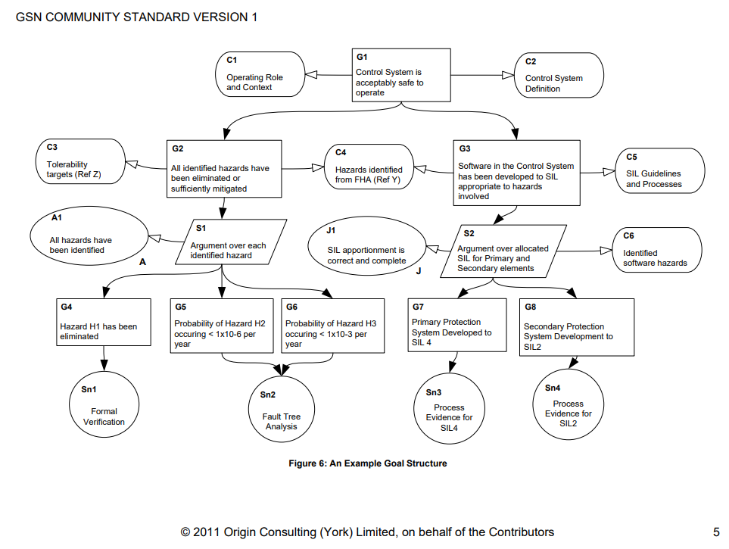

Figure : An Example GSN Diagram from GSN Standards Document

#### EOL Examples on GSN Community Standard Model

Epsilon Object Language helps users to access or update the model elements. Update operations include changing element values, creating new elements and deleting existing elements from the model. Table 14 demonstrates several element queries in the Astah GSN driver.

|  |  |
| --- | --- |
| **Commands** | **Results** |
| gsn.all | All elements (nodes+links) |
| gsn.solution | 4 Solutions elements: Sn1-Sn4 |
| gsn.justification | J1 Justification element |
| gsn.goal.size | 8 – Number of Goals |
| gsn.C6.content | “Identified software hazards” |
| gsn.t_G3_s_G1 | G1-G3 link (Asserted Inference) element |
| gsn.s_g8_t_sn4.target.id | “G8” - G8-Sn4 link (Asserted Evidence) element’s targeted node ID |
| gsn.strategy.last | S2 strategy element |
| gsn.c4.xsi_type | “ARM:InformationElement” – Context element’s xsi:type value |
| gsn.Sn1.content = “Informal Verification”; | Sets Sn1 Solution elements content to “Informal Verification” |
| var newStgy = New Strategy; | Creates a new Strategy element |
| gsn.all.append = newStgy; | Generates a new ID for a new element (S3) and appends it to the model |
| delete C6; | Deletes ID=C6 Context element |

Table : Element Queries on GSN Community Standard Model

#### EVL Examples on GSN Community Standard Model

EVL is used for model validation operations. In this part, 2 different model validation examples shown on the GSN Community Standard model with Astah GSN driver operations. One of the examples is warning and the other one is an error type constraint. If the given Astah GSN XMI file (model) doesn’t validate for these 2 constraints, it will show the error message in the Epsilon console.

The first constraint validation for Standard Community Model is:

* Every Strategy element must have at least one Context connection.

This constraint is just for showing Astah GSN driver’s capabilities, normally GSN models don’t require Strategy-to-Context connections. This validation method was chosen as a warning so it is a critique instead of a constraint. Table 15 shows the constraint validation in EVL.

|  |
| --- |
| **context** strategy {  **critique** StrategyWithoutContext{  **check**{  // Boolean variable for does strategy element have a Context  // connection or not  **var** doesHaveContext = *false*;  // List (Sequence) for holding all Strategy elements' ID for  // warning message.  **var** strategyIdWithoutContext : **Sequence**;  // For loop over all Strategy elements  **for** (stgy **in** *self*.strategy) {  // Reset boolean value for each strategy element  doesHaveContext = *false*;  // For loop over each Strategy elements' each outgoing  // target links  **for** (StrategySources **in** stgy.source) {  /* If Strategy has outgoing links AND  * If outgoing link element's target side node element's  * type is Context, change the boolean value to TRUE  */  **if**(**not** (StrategySources == *null*) **and**  StrategySources.target.gsntype == "Context")  {  doesHaveContext = *true*;  }  }  // If Strategy element doesn't have any connection to  // Context, add its ID into the list  **if**(doesHaveContext == *false*){  strategyIdWithoutContext.add(stgy.id);  }  }  /* After checking every Strategy element, it found some  * Strategies without Context connection --> Give a warning and  * print message.  */  **if**(strategyIdWithoutContext.isEmpty()){  **return** *true*;  }  **else**{  **return** *false*;  }  }  **message**: "Strategy " + strategyIdWithoutContext + " should have an connection to a Context element."  }  } |

Listing : StrategyWithoutContext Validation on GSN Community Standard Model

The second validation example tries to detect Solution elements that don’t have any (incoming) connections.

* Solutions must have at least one incoming link (connection).

It checks every Solution element and if they don’t have an incoming connection link, it adds their IDs in the list to print the error message. Table 16 indicates the EVL code for this constraint.

|  |
| --- |
| **context** solution {  **constraint** SolutionMustHaveConnection {  **check**{  // Sequence for storing Solution IDs for error message  **var** solutionsWithoutConnection : **Sequence**;  // Loop over every solution element  **for**(sol **in** *self*.solution){  // Check if the Solution has an incoming (target)  // connection or not  **if**(sol.target == *null*){  // If target is empty for the given Solution, add its  // ID in list  solutionsWithoutConnection.add(sol.id);  }  }  // Check if there are Solutions without connection or not  // If the list is empty, don't give an error  **if**(solutionsWithoutConnection.isEmpty()){  **return** *true*;  }  **else**{  **return** *false*;  }  }  **message**: "Solutions " + solutionsWithoutConnection + " must have a connection!"  }  } |

Listing : SolutionMustHaveConnection Validation on GSN Community Standard Model

#### EGL Examples on GSN Community Standard Model

Running EGL scripts in Epsilon requires EGX files for filenames. Below EGX script runs given EGL file (GSNModelToHTMLTable.egl) and generates the HTML output file (output.html). It also prints “Transformation starting/finished” before and after the EGL operations. Table 17 shows the EGX script and Table 18 shows the EGL script to generate HTML tables form the GSN model.

|  |
| --- |
| **pre** { "Transformation starting".println(); }  **rule** AstahGSN2HTML  **transform** gsn : GSN {  // EGL file name  **template** : "GSNModelToHTMLTable.egl"  // Output HTML file name  **target** : "output.html"  **post** { "Transformation finished".println(); } |

Listing : HTML Table Generator EGX Script for GSN Community Standard Model

The below code shows the EGL scripts for generating HTML tables from Astah GSN model XMI files. It generates an HTML table with Goal ID, Goal’s number of outgoing links and Goal’ s number of incoming links. The output of this script could be seen below the EGL code.

|  |
| --- |
| <table border="1">  <tr>  <td>Goal ID</td>  <td># Outgoing Connections</td>  <td># Incoming Connections</td>  </tr>  [%**for** (g **in** gsn.goal.sortBy(g|g.id)){%]  <tr>  <td>[%=g.id%]</td>  <td>[%=g.source.size()%]</td>  <td>[%=g.target.size()%]</td>  </tr>  [%}%]  </table> |

Listing : HTML Table Generator EGL Script for GSN Community Standard Model

The output of the EGL script is shown in Table 19. It is not the same number of connections as the GSN model due to XMI file link storage types. It doesn’t store Strategy-to-Goal and Goal-to-Strategy connections as a link element.

* G2 has 5 outgoing link elements: G2-C3, G2-C4, G2-G4, G2-G5 and G2-G6.
* G3 has 4 outgoing link elements: G3-C4, G3-C5, G3-G7 and G3-G8.

|  |  |  |
| --- | --- | --- |
| Goal ID | # Outgoing Connections | # Incoming Connections |
| G1 | 4 | 1 |
| G2 | 5 | 1 |
| G3 | 4 | 1 |
| G4 | 1 | 1 |
| G5 | 1 | 1 |
| G6 | 1 | 1 |
| G7 | 1 | 1 |
| G8 | 1 | 1 |

Table : GSN Model to HTML Table EGL Result

#### ETL Examples on GSN Community Standard Model

In this section, the GSN model will be transformed into a Structured Content model. Figure 6 shows the two models and transformed parts. All GSN model’s nodes transformed to table rows. Nodes’ ID, xsi:type and content attributes transformed to Structured Content’s cells. Transformation ETL script is shown in Table 20 and its output Structured Content model’s XML file is shown in Table 21.

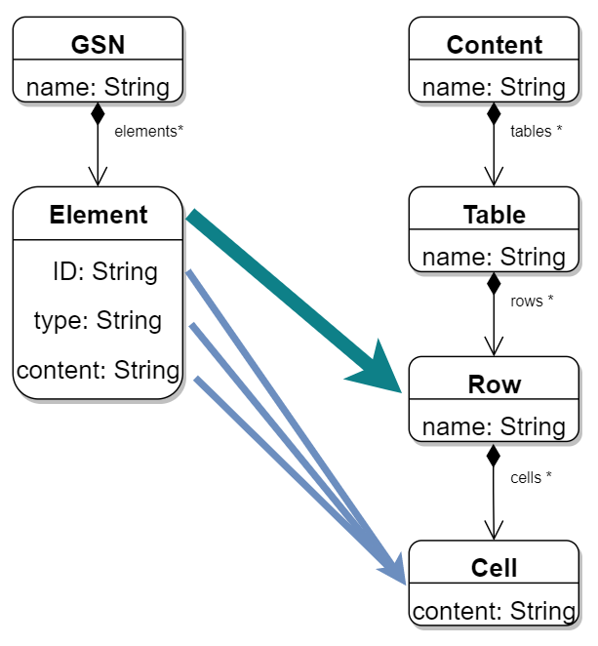

Figure : Astah GSN XMI Model to Structured Content Model Transformation

|  |
| --- |
| **pre** {  "Transformation starting".println();  }  **rule** GSN2EMF  // Source is Astah GSN XMI Model file  **transform** a : Source!GSN  // Target is EMF Structured Element empty model  **to** t : Target!Table {  // Name of the table -> GSN Table  t.name = "GSN Nodes Table";  // Table header row  t.createRow(**Sequence**{"Element ID", "Element Type", "Content"});  // Loop over all nodes and create a new row for each one  **for** (g **in** Source!gsn.nodes.sortBy(g|g.id)) {  t.createRow(**Sequence**{g.id, g.xsi_type, g.content});  }  }  // Create rows in the table  **operation** Target!Table createRow(content : **Sequence**) {  **var** row : **new** Target!Row;  **for** (c **in** content) { row.createCell(c); }  *self*.rows.add(row);  }  // Create cells in the rows  **operation** Target!Row createCell(content : **Any**) {  **var** cell : **new** Target!Cell;  cell.content = content + "";  *self*.cells.add(cell);  }  **post** {  **var** root : **new** Target!Content;  root.tables.addAll(Target!Table.all);  "Transformation finished".println();  } |

Listing : GSN to Structured Content ETL Script for GSN Community Standard Model

The output Structured Model XML file shows the first four rows of the table. Each row represents different node elements and each cell stores these nodes ID, type and content values.

|  |
| --- |
| <?xml version="1.0" encoding="ASCII"?>  <structuredContent:Content xmi:version="2.0"  xmlns:xmi="http://www.omg.org/XMI"  xmlns:xsi="http://www.w3.org/2001/XMLSchema-instance"  xmlns:structuredContent="http://www.example.org/structuredContent"  xsi:schemaLocation="http://www.example.org/structuredContent  StructuredContent.ecore">  <tables name="GSN Nodes Table">  <rows>  <cells content="Element ID"/>  <cells content="Element Type"/>  <cells content="Content"/>  </rows>  <rows>  <cells content="A1"/>  <cells content="ARM:Claim"/>  <cells content="All hazards have been identified"/>  </rows>  <rows>  <cells content="C1"/>  <cells content="ARM:InformationElement"/>  <cells content="Operating Role and Context"/>  </rows>  <rows>  <cells content="C2"/>  <cells content="ARM:InformationElement"/>  <cells content="Control System Definition"/>  </rows>  <rows>  <cells content="C3"/>  <cells content="ARM:InformationElement"/>  <cells content="Tolerability targets (Ref Z)"/>  </rows>  … |

Listing : ETL Script's Output Structured Content Model XML File

### Coffee Cup Safety Standards GSN Model

Coffee cup safety cases GSN diagram is another McMaster master project. This project contains different safety cases for a single coffee cup. Goal structuring notation used to illustrate safety cases. GSN is one of the most popular options for safety case management. Figure 7 shows the top-level GSN diagram for coffee cup safety cases. It has 4 modules: R (Requirements), D (Design), P (Manufacturing) and MD (Maintenance). Figure 8 displays the R module and Figure 9 shows the D module top-level diagrams.

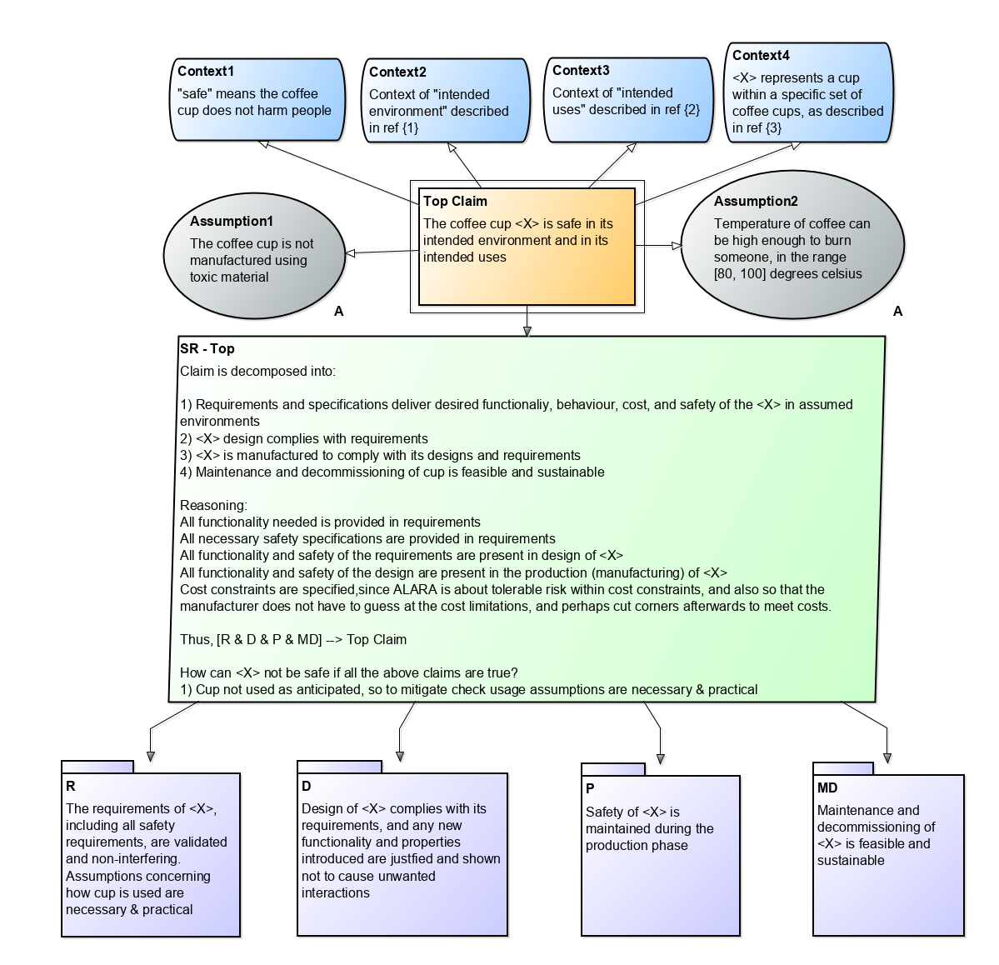

Figure : An Example GSN Diagram for Coffee Cup Safety Cases

Astah GSN XMI file doesn’t store modules thus the user cannot access the modules via Epsilon. Some EOL examples are given below. “C!” part indicates the Astah GSN XMI file. Epsilon can run on multiple model files and for running EOL commands on a specific model, you have to use the model’s name (C in this case) in the run configuration.

|  |  |
| --- | --- |
| **EOL** | **Result** |
| C!gsn.SRTop.content.println(); | Claim is decomposed into: … |
| C!gsn.topclaim.id.println(); | Top Claim |
| C!gsn.assumption1.xmi_id.println(); | _c-Mxh8UxEeq7rp480IS80w |
| C!gsn.context1.id = "C1"; | None (Sets element id) |
| C!gsn.context.id.println(); | Sequence {Context4, Context3, Context2, C1} |

Table : Coffee Cup Safety Case GSN Diagram EOL examples

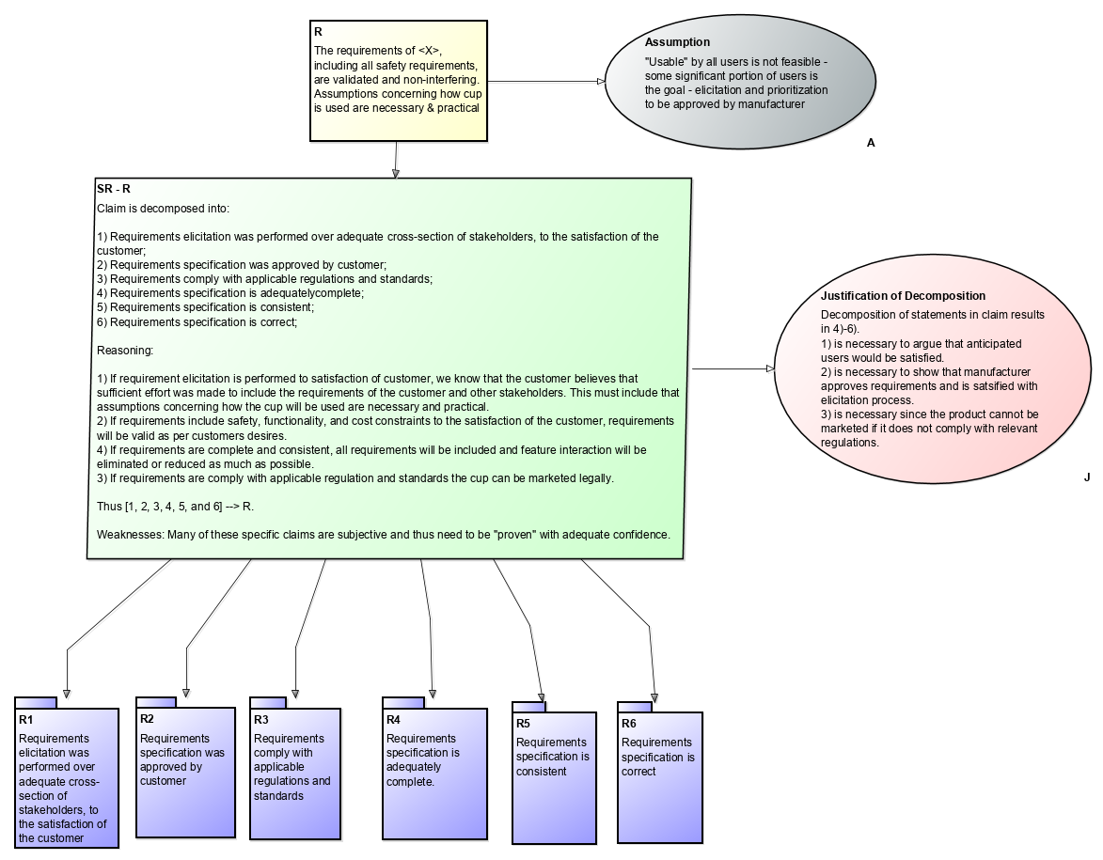

Figure : Coffee Cup Safety Cases GSN Diagram R Module

Validation examples for this GSN model given in Listing 10. Validation checks the R (Requirement) module’s justification element and it should have exactly one source link.

|  |
| --- |
| **context** gsn {  **constraint** JustificationMustHaveAConnection {  **check:** gsn.justificationofdecomposition.source.size() == 1;  **message**: "Justification must have exactly 1 connection!"  }  } |

Listing : Coffee Cup Safety Case GSN Diagram EVL example

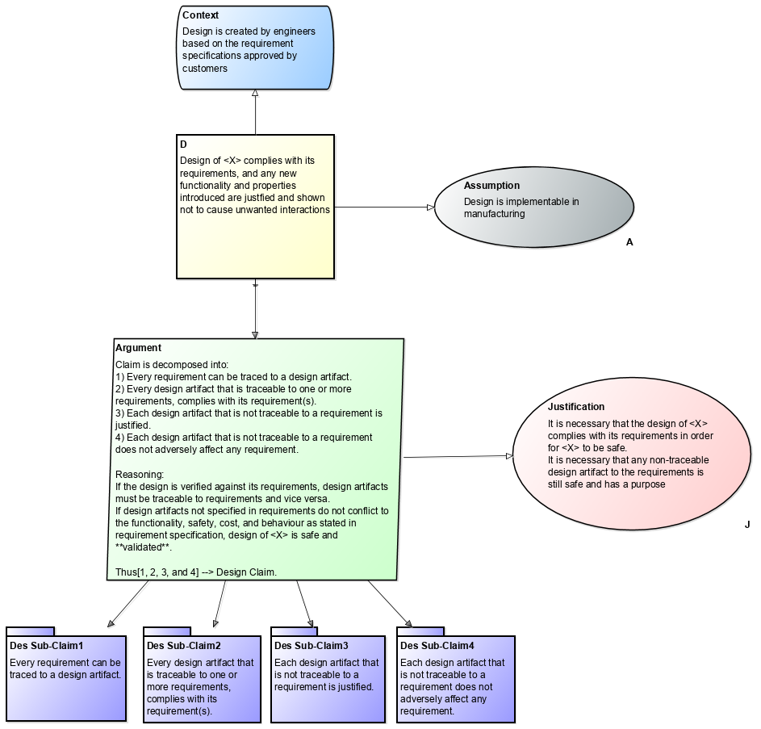

Figure : Coffee Cup Safety Case GSN Diagram D Module

LaTeX table generation EGL script for Coffee Cup Safety Cases GSN diagram is shown in Listing 11. D (Design) module used for this example. It generates a table for each node element. Table’s headers contain node IDs and table cells contain node elements’ content.

|  |
| --- |
| [%  var header = gsn.nodes.id.concat("|");  %]  \begin{longtable} {[%=header%]|}  \hline  [%for (n in gsn.nodes){%]  [%=n.content.concat(" & ")%] \\\hline  [%}%]  \end{longtable} |

Listing : Coffee Cup Safety Case GSN Diagram EGL example

# CONCLUSION

In this project report, challenges in implementing an Epsilon driver for Astah GSN are presented. While Goal Structuring Notations and safety-critical software developments popularity increases day by day, developing an Epsilon driver for one of the most popular GSN tools would not only benefit the GM but also might benefit the other companies as well. The design options, design updates, implementation difficulties and testing methodologies of the Astah GSN Epsilon driver were explained in this report. This driver can work on Astah GSN XMI files with Epsilon’s EOL, EVL, EGL and ETL languages.

## Future Work

This project is a Master of Engineering project and the project time is not limited. Thus, it doesn’t have all the features that I can implement into the Astah GSN driver. For instance, the current version of the driver cannot access or update the Strategy-to-Goal and Goal-to-Strategy link elements due to their storage type in the XMI file. This feature could be implemented in the driver but changing the design of the Astah GSN XMI file would be better for all. Also, for newly created elements unique *xmi:id* values needed. However, without the necessary information for what Astah GSN uses in the ID generation phase, generating new unique IDs might corrupt the whole GSN model. Thus, implementing this feature would require additional information and it might take longer. Moreover, accessing and changing all attributes in the XMI file could be implemented in the driver if necessary.

# REFERENCES

1. M. Brambilla, J. Cabot and M. Wimmer, *Model-Driven Software Engineering in Practice.* 2012. pp. 1-23.
2. D. C. Schmidt, “Model-Driven Engineering”, *Computer-IEEE Computer Society*, vol. 39, no. 2, pp. 25-31, 2006.
3. MIT OpenCourseWare, (2016). Systems Theoretic Process Analysis (STPA). [Online]. Available: [https://ocw.mit.edu/courses/aeronautics-and-astronautics/16-63j-system-safety -spring-2016/lecture-notes/MIT16_63JS16_LecNotes10.pdf](https://ocw.mit.edu/courses/aeronautics-and-astronautics/16-63j-system-safety%20-spring-2016/lecture-notes/MIT16_63JS16_LecNotes10.pdf). Accessed: Jul. 10, 2020.
4. N. G. Leveson and J. Moses, *Engineering a Safer World: Systems Thinking Applied to Safety*. Cambridge: MIT Press, 2012, pp. 1-249. [Online]. Available: <https://ebookcentral.proquest.com/lib/mcmu/reader.action?docID=3339365>. Accessed: Jul. 10, 2020.
5. T.P. Kelly, “Arguing Safety: A Systematic Approach to Managing Safety Cases”, Ph.D. dissertation, Dept. Comp. Sci., Univ. of York, York, UK, 1999.
6. T. Ishimatsu, N. G. Leveson, J. Thomas, M. Katahira, Y. Miyamoto, and H. Nakao, “Modeling and Hazard Analysis Using STPA”, in *International Association for the Advancement of Space Safety*, AL, USA, May 19-21, 2010.
7. R. Weaver, J. Fenn and T. Kelly, “A Pragmatic Approach to Reasoning About the Assurance of Safety Arguments”, in *Proceedings of the 8th Australian workshop on Safety-critical systems and software*, Australia, 2003, pp. 57-67.
8. T. Kelly, “A Systematic Approach to Safety Case Management”, *SAE transactions,* pp. 257-266, 2004.
9. T.P. Kelly and J.A. McDermid, “A Systematic Approach to Safety Case Maintenance”, in *International Conference on Computer Safety, Reliability, and Security*, Springer, Berlin, Heidelberg, 1999, pp. 13-26.
10. Epsilon, “Eclipse Epsilon”, 2020. [Online]. Available: <https://www.eclipse.org/epsilon>. Accessed: Jul. 04, 2020.
11. D. Kolovos, L. Rose, A. García-Domínguez and R. Paige, *The Epsilon Book.* 2010. [Online]. Available: <https://www.eclipse.org/epsilon/doc/book/EpsilonBook.pdf>. Accessed: Jul. 10, 2020.
12. D.S. Kolovos, R.F. Paige and F.A. Polack, “The Epsilon Object Language (EOL)”, in *European Conference on Model-Driven Architecture-Foundations and Applications*, Springer, Berlin, Heidelberg, 2006, pp. 128-142.
13. A. Zolotas, H.H. Rodriguez, S. Hutchesson, B.S. Pina, A. Grigg, M. Li, D.S. Kolovos and R.F. Paige, “Bridging Proprietary Modelling and Open-Source Model Management Tools: the Case of PTC Integrity Modeller and Epsilon”. *Software and Systems Modelling*, vol. 19, no. 1, pp. 17-38, 2020.
14. EpsilonLabs, “Epsilon-HTML Integration”, 2020. [Online]. Available: <https://github.com/epsilonlabs/emc-html>. Accessed: Jul. 04, 2020.
15. Object Management Group (OMG), “XML Metadata Interchange (XMI) Specification”, 2020. [Online]. Available: <https://www.omg.org/spec/XMI/2.5.1/PDF>. Accessed: Jul. 04, 2020.
16. The GSN Working Group Online, “GSN Community Standard Verison 1”, 2011. [Online]. Available: [http://www.goalstructuringnotation.info/documents/GSN _Standard.pdf](http://www.goalstructuringnotation.info/documents/GSN%20_Standard.pdf). Accessed: Jul. 08, 2020.